Aumsville Rural Fire Protection District
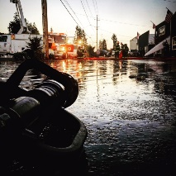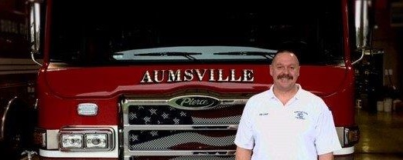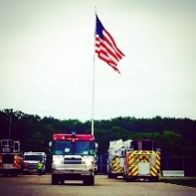
490 Church Street, P.O. Box 247, Aumsville, Oregon 97325-0247
(503) 749-2894 Fax (503) 749-2182 - Email admin@aumsvillefire.org

BOARD OF DIRECTORS SPECIAL MEETING
490 Church Street, Aumsville
February 23, 2017
Revised Minutes
Call to order: Meeting called to order by President Heffner at 1809 hours (6:09 pm).

Attendance:
Board members: Garvin Smith, Michael Heffner, Wayne Kuhl, Robert Garrison, Rachel Fellis
Staff: Chief Terrill Isaak, Assistant Chief Brad McKenzie, Apparatus Maintenance Officer Chris Lorenz, and Office Administrator Trish Lutgen
Volunteers: Brad Buchholz

Flag salute: Completed.

Approval of Agenda: Action: Motion was made by Director Garrison to approve the agenda as presented, motion seconded by Director Fellis. And, with no discussion or changes the motion carried unanimous.

Minutes: Board Minutes from February 9, 2017. Action: Motion to approve minutes as presented with no changes by Director Garrison, motion seconded by Director Fellis. And, with no discussion the motion passes unanimous.

Public Comment (Agenda Items): None.

New Business:
- SDAO Board Practices Assessment Presentation. George Dunkel, SDAO (Special Districts Association of Oregon) Consulting Services Administrator, presented the SDAO Board Practices Assessment brochure which is a free service and if completed by the Board gives the district a 2% discount on our insurance premium. Discussion occurred around the program. Director Smith wanted to look at now till March to schedule an assessment. Director Garrison suggested having Trish facilitate getting a date schedule. Director Kuhl asked if Trish was okay working with SDAO to schedule an assessment. Trish was okay working with SDAO to schedule.

- Chief Isaak Appointment. The Board went over the SDAO material. Discussion occurred with George Dunkel around the SDAO proposal for finding an interim Chief.
  - Heffner addressed the issue of not having someone in place by the time Chief leaves and if Brad’s position allowed him to cover. It was pointed out that it will only be a short time between when Chief leaves and an interim is placed.
  - President Heffner requested a board discussion due to some anxiety in the community. Director Smith mentioned that when it was just Terrill there were 50-70 calls and people got tired, so he was interested in going with SDAO. Director Garrison felt that utilizing SDAO services would give the board time to work on finding a qualified Chief. Director Kuhl believes there should be two people in a staff position. And, Director Fellis agrees with everyone.
  - Further discussion regarding a dollar figure that would not negatively impact the budget occurred. Chief Isaak stated that the district could easily afford 85,000.
Action: Motion to allow President Heffner to negotiate up to $7250 per month with SDAO for interim Fire Chief services made by Director Kuhl, motion seconded by Director Garrison. And, with no further discussion the motion passes unanimous.
  - George will start getting stuff together tomorrow morning. He will include President Heffner, Director Garrison and Trish in the communications.

Public Comment (other than agenda items): None.

Executive Session: Per ORS 192.660 (2)(i), the board went into executive session for evaluation of the fire chief at 1907 hours (7:07 pm). The Board returned from executive session at 2019 hours (8:19 pm).

Next Meeting Date:
- The next regular meeting to occur on March 9, 2017 at 1730 hours (5:30 pm) at 490 Church Street, Aumsville, OR 97325.
- Per ORS 192.660 (2)(i), to review the Chief’s evaluation, the regular meeting will include an executive session.

Adjourn: Action: Motion to adjourn by Director Smith, motion seconded by Director Kuhl. And, with no discussion the motion carried unanimous adjourning the meeting at 2020 hours (8:20 pm).

Secretary ______________________________________ Date: __________________

Michael Heffner, President ______________________________________ Date: __________________

