Aumsville Rural Fire Protection District
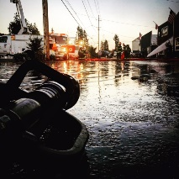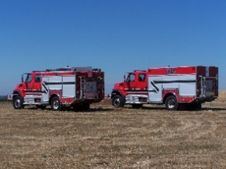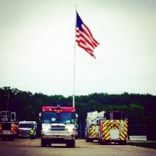
490 Church Street, P.O. Box 247, Aumsville, Oregon 97325-0247
(503) 749-2894 Fax (503) 749-2182 - Email admin@aumsvillefire.org

BOARD OF DIRECTORS MEETING MINUTES
490 Church Street, Aumsville
NOVEMBER 20, 2017

Call to order: Meeting called to order by President Kuhl at 1800 hours or 6:00 pm.

Attendance:
Board members: Wayne Kuhl, Garvin Smith, Rachel Fellis, Robert Garrison
Staff: Chief Roy Hari, Office Administrator Trish Lutgen
Volunteer firefighters: Odas Coleman, Brandon Lauritzon, Eric Pineda, Storm Morlan, Janet Schaefer, Sally Kelly
Special guests: Stephanie Stafford, Matthew Etzel

Flag salute: Completed.

Approval of Agenda: Action: Motion to approve the agenda as presented made by Director Garrison, motion seconded by Director Fellis. Motion carried unanimous.

Old Business:

- Board Vacancy.
  - President Kuhl read a letter dated November 13, 2017 from Royce Morlan removing his name for consideration for the vacant board position.
  - Action: Director Fellis moved to rescind the previous motion from the November 9, 2017 board meeting to send a letter to the commissioner and move forward with a vote, Director Garrison seconded. Motion carried unanimous.
  - Questions were asked of both candidates by Director Smith that were like the questions asked at the November 9th meeting.
  - Director Kuhl stated that he would entertain a vote. Director Fellis voted for Stephanie. Director Garrison voted for Matthew. Director Smith voted for Stephanie. President Kuhl voted for Stephanie. A majority decision was reached. Congratulations to Stephanie. She will be sworn in at the next meeting. Trish gave Director Stafford prior board packets.
- Conflagration Policy.
  - Chief Hari presented the draft policy for mobilization. We will not drop our resources below 12 people to maintain service in the District. The policy covers all our apparatus. And, we will need to be ready to leave within 30 minutes and have supplies for 5 days.
  - We need to have the board adopt something regarding to compensation. Chief states that there is a risk to the District. He has never been low balled by the state. Discussion occurred around the presented policy.
  - President Kuhl asked Chief to explain the notice of claim. Discussion around the state’s notice of claim, time lines, and payroll period. Discussion around paying 10 business days occurred.
  - Action: Director Garrison moved to pay the CA conflagration as soon as possible and modify the policy to pay people in 10 days, seconded by Fellis. Motion carried unanimous.

Information/Good of the Order: Odas wanted to thank Director Smith for calling at the Turkey Shoot. The volunteers appreciated the support from both Director Smith and Director Kuhl. Director Garrison wanted to know how the volunteers did. Odas stated that there was 490 people and $2,500 donations and $2,200 in sponsorships. Odas wanted to thank Brad and the paid guys for cleaning the bays, so the volunteers did not have much to do as far as setup.

Next Meeting Date: December 14, 2017 at 1800 hours (6:00 pm) at 490 Church Street, Aumsville OR 97325.

Adjourn: Action: Motion to adjourn by Director Smith, motion seconded by Director Garrison. Motion carried unanimously adjourning the meeting at 1844 hours (6:44 pm).

Rachel Fellis, Secretary ______________________________________ Date: __________________

Dusty Kuhl, President ______________________________________ Date: __________________

