Aumsville Rural Fire Protection District
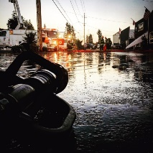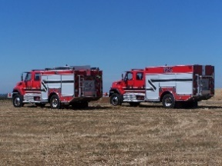
490 Church Street, P.O. Box 247, Aumsville, Oregon 97325-0247
(503) 749-2894 Fax (503) 749-2182 - Email admin@aumsvillefire.org

BUDGET COMMITTEE MEETING
490 Church Street, Aumsville
May 9, 2019 at 6:30pm
Agenda
WELCOME: Chief Hari
Introduction of Members: Nico Casarez, Cindy Gordon, Matthew Etzel, Crystal Kluver, Kathryn Nichol

SIGN-UP: Public input is welcome. You are required to sign up on the sheet provided indicating your name, address, and the general topic. The Budget Committee may assign a particular order for your input on the agenda.

CALL TO ORDER: Board President

FLAG SALUTE

BUDGET PROCESS REVIEW: Chief Hari

ELECT PRESIDING OFFICER (Committee Chair) Board President

APPROVAL OF AGENDA: Committee Chair

PUBLIC COMMENT:

BUDGET MESSAGE AND PROPOSED BUDGET DOCUMENTS: Chief Hari
General Fund 1
Special Fund Debt Service 2
Reserve Fund 4 – Apparatus
Capital Projects – Bond Fund 5
Reserve Fund 6 – Equipment
Reserve Fund 7 – Property and Facilities

COMMITTEE DELIBERATIONS (Amendments as needed) Committee

ACTION ITEMS:
- Approve and recommend proposed budget to the board Committee
- Approve and recommend tax rate to the board Committee
- Approve and recommend general obligation bond levy rate Committee

ADJOURNMENT Committee Chair

NEXT MEETING DATES Budget Hearing June 13, 2019 at 6:30pm

