Aumsville Rural Fire Protection District
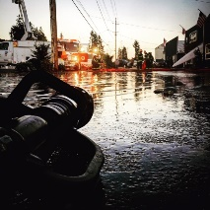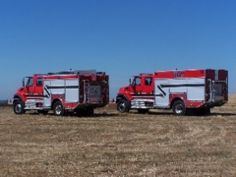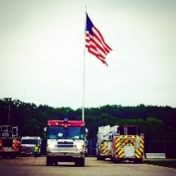
490 Church Street, P.O. Box 247, Aumsville, Oregon 97325-0247
(503) 749-2894 Fax (503) 749-2182 - Email aumsville@aumsvillefire.org

BOARD OF DIRECTORS SPECIAL MEETING MINUTES
490 Church Street, Aumsville
August 19, 2019

Call to order: Meeting called to order by President Garrison at 18:30 hours or 6:30 p.m.

Attendance:
Board members: Wayne Kuhl, Garvin Smith, Rachel Fellis, Joshua Phillis, and Robert Garrison
Volunteers: Mark Noack
Staff: Chief Roy Hari and Office Administrator Trish Lutgen
Special Guest: Julie Whitehurst, Realtor

Flag salute: Completed.

Public Comment: None

Property Tour: Julie Whitehurst, Realtor, introduced herself, and the board went to tour the property at 145 N 4th Street, Aumsville. The board returned from the tour at 6:47p.m.

Executive Session: The board moved into executive session at 6:50 p.m. to conduct deliberations with persons designated by the governing body to negotiate real property transactions per ORS 192.660(2)(e) and to consider information or records that are exempt by law from public inspection per ORS 192.660(2)(f). The board returned from executive session at 7:25 p.m.

Property Purchase: Action: Motion to purchase the property at 145 N 4th Street in Aumsville for $175,000 and allow President Garrison to sign the real estate sale agreement, subject to some language changes by Director Fellis, motion seconded by Director Smith. Motion carried unanimously.

Good of the Order: President Garrison reached out to the Turner Board President to open dialogue on options to work together on doing things better. Preliminary conversations occurred. Ed Humber is Turner’s Board President.

Next meeting is September 12, 2019 at the Aumsville Station at 1830 hours or 6:30 p.m.

Adjourn: Action: Motion to adjourn by Director Kuhl, motion seconded by Director Phillis. Motion carried unanimously adjourning the meeting at 1930 hours (7:30 p.m.).

Rachel Fellis, Secretary ______________________________________ Date: __________________

Robert Garrison, President ______________________________________ Date: __________________

