Aumsville Rural Fire Protection District
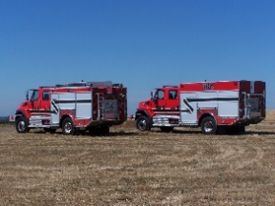
490 Church Street, P.O. Box 247, Aumsville, Oregon 97325-0247
(503) 749-2894 Fax (503) 749-2182 - Email aumsville@aumsvillefire.org

BOARD OF DIRECTORS SPECIAL SESSION MINUTES
490 Church Street, Aumsville
APRIL 25, 2018

Call to order: Meeting called to order by President Kuhl at 1800 hours or 6:00 pm.

Attendance:
Board members: Wayne Kuhl, Rachel Fellis, Garvin Smith, and Stephanie Stafford
Staff: Chief Roy Hari, and Office Administrator Trish Lutgen
Volunteer firefighters:

Flag salute: Completed.

Approval of Agenda: Amended the agenda to include public comment. Action: Motion to approve the agenda with the addition made by Director Fellis, motion seconded by Director Smith. Motion carried unanimous.

Public Comment: None.

Executive Session: Per ORS 192.660(2)(i) to review and evaluate the employment-related performance of the chief executive officer of any public body, a public officer, employee or staff member who does not request an open hearing, the board recessed to Executive Session at 1801 hours or 6:01 pm.

The board returned from executive session at 1848 hours or 6:48 pm.

Adjourn: Action: Motion to adjourn by Director Smith, motion seconded by Director Stafford. Motion carried unanimously adjourning the meeting at 1849 hours (6:49 pm).

Rachel Fellis, Secretary ______________________________________ Date: __________________

Dusty Kuhl, President ______________________________________ Date: __________________

