Aumsville Rural Fire Protection District
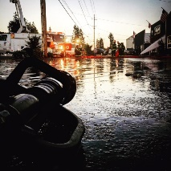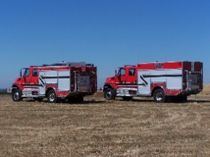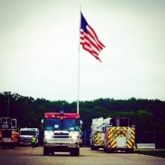
490 Church Street, P.O. Box 247, Aumsville, Oregon 97325-0247
(503) 749-2894 Fax (503) 749-2182 - Email aumsville@aumsvillefire.org

BOARD OF DIRECTORS REGULAR MEETING MINUTES
390 Church Street, Aumsville
September 12, 2019

Call to order: Meeting called to order by President Garrison at 18:40 hours or 6:40 p.m.

Attendance:
Board members: Garvin Smith, Rachel Fellis, and Robert Garrison
Staff: Chief Roy Hari and Office Administrator Trish Lutgen
Volunteers: Robert Surette

Flag salute: Completed.

Agenda: Action: Director Fellis made a motion to approve the agenda as presented, seconded by Director Smith. Motion carried unanimous.

Swearing in of New Directors: Swearing in of Wayne Kuhl will need to occur at the next meeting.

Minutes: Action: Director Fellis made a motion to approve the August 8, 2019 minutes as presented, seconded by Director Smith. Motion carried unanimous. Director Fellis made a motion to approve the August 19, 2019 minutes as presented, seconded by Director Smith. Motion carried unanimous.

Treasurer Report: As presented in the packet.

Volunteer Association: November 23rd is the Turkey Shoot. It will be the 75th year. The hours are from 6 – 10 p.m. Director Smith would like to do some give-a-ways. Chief Hari would like to do something for the kids.

Public Comment: None

Old Business:
- Knight Property: President Garrison read into record resolution 2019-05 A Resolution Authorizing a Full Faith and Credit Borrowing and Related Matters. Action: Director Smith made a motion to approve the Resolution 2019-05 and to have President Garrison sign the fiscal documents, seconded by Director Fellis. Motion carried unanimous. Trish gave an update on the title report and the EAP report, reporting that there was nothing out of the norm and it was okay to move forward.

- Chief’s Review: Tabled until next month.

- Wage Schedule: Chief Hari is working on the wage schedule.

- Strategic Plan: Chief Hari is putting it to print.

New Business:

Station Tour: Chief stated that the Board needed to pick a date to tour the Clackamas station, which is brand new.

Chief’s Report: Someone backed into the Shaw station today. We will be sending an engine to attend a funeral of Cheryl Harris, who was a prior Support Team member. The OFDDA conference will be occurring in November. Please let Trish know if you are attending, so that she may get everyone registered. Next month, there will be an Armed Service Insurance presentation. We will be pump testing with Stayton. We are in the midst of migrating from the cloud to the server. And, we will be installing the new door locks this month.

Good of the Order: Director Smith is switching jobs. He might be missing a couple of meetings. Tomorrow Directors Kuhl and Smith will be participating in the SDAO Golf Tournament.

Public Comment: None

Next meeting is October 10th at the Aumsville station at 1830 hours or 6:30 p.m.

Adjourn: Action: Motion to adjourn by Director Fellis, motion seconded by Director Smith. Motion carried unanimously adjourning the meeting at 1950 hours (7:50 p.m.).

Rachel Fellis, Secretary ______________________________________ Date: __________________

Robert Garrison, President ______________________________________ Date: __________________

