Aumsville Rural Fire Protection District
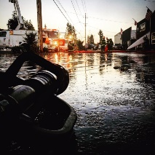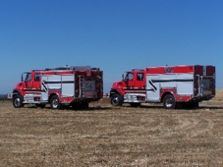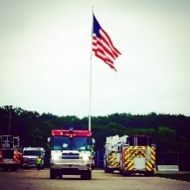
490 Church Street, P.O. Box 247, Aumsville, Oregon 97325-0247
(503) 749-2894 Fax (503) 749-2182 - Email aumsville@aumsvillefire.org

BOARD OF DIRECTORS REGULAR MEETING MINUTES
490 Church Street, Aumsville
December 10, 2020

Call to order: The online meeting called to order by President Garrison at 18:37 hours or 6:37 p.m.

Attendance:
Board members: Joshua Phillis, Rob Garrison, Wayne Kuhl (online), and Rachel Fellis
Staff: Chief Roy Hari, Captain Brad McKenzie, and Office Administrator Trish Lutgen

Agenda: Action: Director Fellis made a motion to approve the agenda as presented, seconded by Director Kuhl. Motion carried unanimous.

Minutes: November 12, 2020 Meeting Minutes. Action: Director Kuhl made a motion to approve the minutes as presented, seconded by Director Phillis. Motion carried unanimous.

Treasurer Report: As presented in the packet.

Volunteer Association: None

Public Comment (Agenda): None.

Old Business:
- Public Contracting Policy: Schedule the meeting for January. The Board had no questions but requested a checklist for the hearing in January.

New Business:
- SDIS Annual Evaluation: As presented in the packet. Chris Lorenz did the evaluation this year.

Chief’s Report: Chief Hari updated the Board on Marion County Fire District #1 losing their levy and will be laying off firefighters. We will be having nine folks go through academy in January. The District has had one person self-quarantining due to COVID-19. The Aumsville station is now closed to the public. Social distancing and mask precautions are taking place inside the station.
We lost Koumentis as a part-timer. He was offered a full-time position with Sheridan. Mix will be taking his place. We’ve had seven part-time employees get hired out full-time.
Captain McKenzie was able to get us a COVID grant that will secure us two Owl Labs meeting Owls (a video conference camera, microphone, and speaker) for meetings and a backpack for disinfecting.
President Garrison asked if 305 will be available for runs. Chief didn’t know if a call at Macleay occurred if Engine 10 or Aumsville would respond. Discussion around Macleay occurred.
President Garrison asked if all of the gloves that were donated had been dispersed. Chief Hari stated that Lyons, Silverton, Marion County, and Scio had all received gloves to date.

Good of the Order: Trish announced that the SDAO Conference would be online February 3rd & 4th. Registration was now open and if any of the board members would like her to register them to let her know.

Public Comment (other than agenda items): None

Next meeting will be on January 14, 2020 at 1830 hours or 6:30 p.m. and the plan is for it to be online.

Adjourn: Action: Motion to adjourn by Director Kuhl, motion seconded by Director Fellis. Motion carried unanimously adjourning the meeting at 1904 hours (7:04 p.m.).

Rachel Fellis, Secretary ______________________________________ Date: __________________

Robert Garrison, President ______________________________________ Date: __________________

