Aumsville Rural Fire Protection District
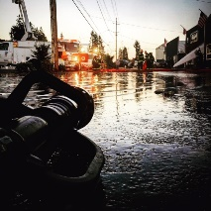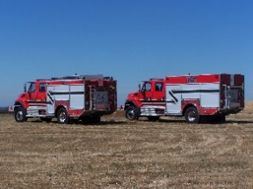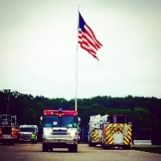
490 Church Street, P.O. Box 247, Aumsville, Oregon 97325-0247
(503) 749-2894 Fax (503) 749-2182 - Email admin@aumsvillefire.org

BOARD OF DIRECTORS WORK SESSION MEETING
490 Church Street, Aumsville
JUNE 01, 2017
Minutes
Call to order: Meeting called to order by President Heffner at 1811 hours.

Attendance:
Board members: Garvin Smith, Michael Heffner, Rachel Fellis, Robert Garrison, Wayne Kuhl
Staff: Chief Roy Hari, Office Administrator Trish Lutgen
Volunteer Firefighters:

Approval of Agenda: Action: Motion to approve the agenda as presented by Director Kuhl, motion seconded by Director Garrison. And, with no discussion or changes the motion carried unanimous.

Work Session:
- Good Steward:
  - Strategic Plan was approved and will be used as a tool to guide us moving forward.
  - Inquire about a reference for laws that pertain to fire districts.

- Good Governance:
  - Director Kuhl wants to be familiar with laws and how they apply.
  - Directors felt that the SDAO trainings would also be helpful.

- Operational Compliance:
  - Director Smith is worried about volunteers. This is a possible area where a committee could be formed.
  - Board members will start to communicate with the Chief.

- Budget:
  - Continue as is, following the current practices.

- Customer Relations:
  - Look at starting a volunteer committee.

- Personnel:
  - Staff morale: Establish a volunteer/staff appreciation.
  - Management of employee performance: Chief Hari is working on a new employee performance review that can be used for everyone.
- Work Assignments:
  - Create an Organizational Chart
  - Create a level of command.
  - Updating the Chief Position Description

Next Meeting Date: June 8th at 1800 hours (6 pm) at 490 Church Street, Aumsville OR 97325

Adjourn: Action: Motion to adjourn by Director Kuhl, motion seconded by Director Fellis. And, with no discussion or changes the motion carried unanimously adjourning the meeting at 2005 hours (8:05 pm).

Wayne Kuhl, Secretary ______________________________________ Date: __________________

Michael Heffner, President ______________________________________ Date: __________________

