Aumsville Rural Fire Protection District
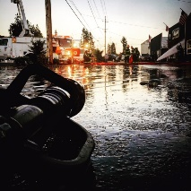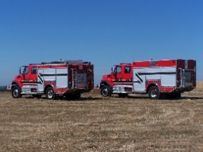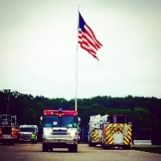
490 Church Street, P.O. Box 247, Aumsville, Oregon 97325-0247
(503) 749-2894 Fax (503) 749-2182 - Email admin@aumsvillefire.org

BOARD OF DIRECTORS WORK SESSION MEETING
490 Church Street, Aumsville
JUNE 29, 2017
Revised Minutes
Call to order: Meeting called to order by President Heffner at 1807 hours.

Attendance:
Board members: Garvin Smith, Michael Heffner, Rachel Fellis, Wayne Kuhl
Staff: Chief Roy Hari, Office Administrator Trish Lutgen, Apparatus Mechanic Chris Lorenz
Volunteer Firefighters: Odas Coleman
Special Guest: Rob Mills, SDAO

Approval of Agenda: Action: Motion to add GBC construction proposal to the agenda by Director Kuhl, motion seconded by Director Fellis. And, with no discussion or changes the motion carried unanimous.

Work Session:
Meeting turned over to Rob Mills to cover Board Assessment. Rob asked what the board would like to accomplish. From notes of last work session board wants to make sure they are on track with correcting the issues found through the assessment.

- Good Steward:
  - Rob is looking for a documented action plan with SMART goals. June 1 work session was addressed by the group. President Heffner addressed the strategic plan.
  - The group would like Trish to pull the OARs and send a follow up email to SDAO member services and George Dunkel to see if something already exists. Inquire about a reference for laws that pertain to fire districts.

- Good Governance:
  - Rob suggested the SDAO conference in Seaside in February.
  - Chief Hari addressed the “danger” item and felt that it could be moved out of the danger area.

- Operational Compliance:
  - The Board felt that this would not be the same conversation today.

- Budget:
  - The previous Chief Isaak gets credit for our current budget quality.

- Customer Relations:
  - Chief Hari believes that the public thinks we are good.
  - Director Kuhl felt that this district has always been blessed with excellent equipment.

- Personnel:
  - Action for staff morale: having a representative at the association meetings. Director Kuhl stated that he would like the volunteer committee to address the volunteer meetings.
  - Chief Hari addressed the negative culture. We need to spread the messages.
  - Director Smith gave kudos to Trish for keeping them on target.
  - Chief Hari addressed the current relationship with the press. The Stayton Mail has some really good articles.
  - Employee Performance: The performance review is so important. It will be addressed at the next regular board meeting. Chief Hari has worked on the position descriptions they will be addressed at the next meeting.
- Work Assignments:
  - Chief Hari mentioned the lack of chain of command. Rob Mills asked what models that Chief Hari used to get volunteers. Chief Hari stated that the tax rules have killed us with the volunteers.
  - Board members who were prior volunteer firefighters talked about how they responded it wasn’t about the money.
  - Chief Hari addressed the items of policies and procedures. Two volunteers are currently working on updating these.
Rob Mills appreciated the in-person 90-day experience and felt that it changed the dynamic.

GBC Construction Information: Quotes from GBC construction was given to the board. Director Kuhl requested a brief statement or a more detailed scope of work to be done. He would like a picture of what the work will entail. President Heffner requested a strategic plan for the building. Director Smith would like to see us go for a grant for an exhaust system.

Next Meeting Date: June 8th at 1800 hours (6 pm) at 490 Church Street, Aumsville OR 97325

Adjourn: Action: Motion to adjourn by Director Kuhl, motion seconded by Director Fellis. And, with no discussion or changes the motion carried unanimously adjourning the meeting at 1955 hours (7:55 pm).

Wayne Kuhl, Secretary ______________________________________ Date: __________________

Michael Heffner, President ______________________________________ Date: __________________

