Aumsville Rural Fire Protection District
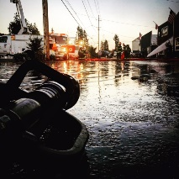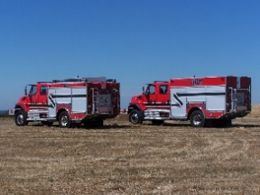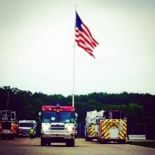
490 Church Street, P.O. Box 247, Aumsville, Oregon 97325-0247
(503) 749-2894 Fax (503) 749-2182 - Email aumsville@aumsvillefire.org

BOARD OF DIRECTORS REGULAR MEETING MINUTES
490 Church Street, Aumsville
July 12, 2018

Call to order: Meeting called to order by President Kuhl at 18:00 hours or 6:00 pm.

Attendance:
Board members: Wayne Kuhl, Garvin Smith, and Rachel Fellis
Staff: Chief Roy Hari, and Office Administrator Trish Lutgen
Volunteers: Lieutenant Surette, Lieutenant Noack, Nic Schrock, Bradley Buchholz, Jeff Morrison, Buffie Morrison, and Lieutenant Coleman

Flag salute: Completed.

Approval of Agenda: Additions to New Business item 2 Aug. board meeting and Good of the Order Policies and Procedures binder. Action: Motion to approve the agenda with the changes made by Director Fellis, motion seconded by Director Smith. Motion carried unanimous.

Minutes: June 14, 2018 Budget Committee meeting minutes. Action: Motion to approve the June 14, 2018 Meeting minutes made by Director Smith, motion seconded by Director Fellis. Motion carried unanimous.

Secretary/Treasurer Report: As presented in the packet.

Public Comment (Agenda Items): None.

Volunteer Association: Surette talked about the pancake breakfast coming up in August 18th. The volunteers would like the board to attend and help. The volunteers are also preparing for conflagration. Chief prefers established teams. Discussion occurred around conflagrations.

Chief presented Nic Schrock with his five-year service award and talked about Nic job shadowing with Lieutenant Coleman. Chief also thanked Lieutenant Noack, Firefighter Buchholz, and Firefighter Stevens for showing up and making such a great presence at the Marion County Fair.

Chief also stated that we have also replaced the badges so they all match.

Old Business:
- Beautification project: Shaw Station: TCB Construction has fixed the drainage cap and tile. The problem is occurring from the school bus turning around in the driveway. The cost is about double of the initial quote that was given. Trish stated that she has received a load of hog fuel from both Director Smith and the City of Aumsville; both loads were donated. We are just waiting for the correction crew to contact about time to go out to plant and spread the hog fuel.

- Board Policy 2.1(c) Qualifications/Tender: Due to the insurance not covering the Board Member, the board would like to leave this policy alone.

- Bradley Property: Mr. Bradley stated he barely remembers the property being a service station. Soil samples have never to his knowledge been completed, and he does not know if the tanks are still there. The district will contact Special Districts Association of Oregon to find out who and what the fee would be. Mr. Bradley gave his permission publicly for us to go on the property, take samples, etc. Chief stated that we just need to do our due diligence. Lieutenant Surette stated that he can give Chief Hari Chris Brenemen’s phone number, this is who did a report the first time that there was discussion of purchasing the property.

New Business:
- Election of Officers: President Kuhl opened nominations. Director Fellis asked if this could wait until the full board was present. President Kuhl stated that policy stated it needed to be done tonight. Director Smith nominated President Kuhl for President. Director Fellis nominated Director Garrison for Vice-President. Director Smith nominated Director Fellis for Secretary. All position votes were unanimous. The positions remain the same.
- August Meeting: Chief Hari will not be here for the Board Meeting on August 9th. Discussion occurred. The board decided to move the meeting to August 2nd.

Chief’s Report: As presented in packet.

Good of the Order: Trish was appointed to the OFSOA board. Nic had a baby – Congratulations to the Schrock family! Discussion occurred around the fire and Jeff’s photography. Thank you to Jeff and Buffie for the work you are doing.

Public Comment (other than agenda items). None.

Next meeting is August 2nd and will also be the Board Assessment at 6:00 pm.

Adjourn: Action: Motion to adjourn by Director Smith, motion seconded by Director Fellis. Motion carried unanimously adjourning the meeting at 1838 hours (6:38 pm).

Rachel Fellis, Secretary ______________________________________ Date: __________________

Dusty Kuhl, President ______________________________________ Date: __________________

