Aumsville Rural Fire Protection District
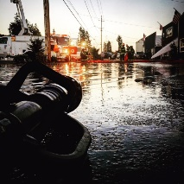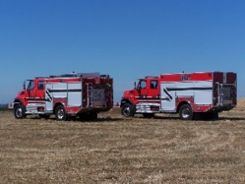
490 Church Street, P.O. Box 247, Aumsville, Oregon 97325-0247
(503) 749-2894 Fax (503) 749-2182 - Email aumsville@aumsvillefire.org

BOARD OF DIRECTORS SPECIAL SESSION MEETING MINUTES
490 Church Street, Aumsville
April 4, 2019

Call to order: Meeting called to order by Vice-President Garrison at 18:30 hours or 6:30 p.m.

Attendance:
Board members: Garvin Smith, Stephanie Stafford, Rachel Fellis, and Robert Garrison
Staff: Chief Roy Hari, Office Administrator Trish Lutgen
Volunteers: Rodney Lutgen
Guests: Carrie Connelly, General Legal Counsel and Joshua Phillis, Position 1 Candidate

Flag salute: Completed.

Secretary of State Letter: Trish presented the letter from the Secretary of State explaining that it sounded scary. Per Amy Dale from the Secretary of State’s office, due to new legislation, we just need to send a letter explaining that due to our size we would not be hiring additional office staff in order to segregate duties. Action: Motion to have Chief and President Kuhl sign and send the response letter to the Secretary of State’s office made by Director Stafford, motion seconded by Director Fellis. Motion carried unanimous.

Appoint Negotiator: Introductions to Carrie Connelly were made and her background was provided. Discussion occurred around the process. Action: Motion to appoint Carrie Connelly as negotiator for the Bradley Property was made by Director Fellis, motion seconded by Director Stafford. Motion carried unanimous.

Surplus: Discussion occurred around the exercise equipment in the bay. Director Smith stated that many of the items were donated or provided by the volunteers. Trish explained that she was pretty sure the Bowflex was purchased with District money. It would cost more for the Board to have her research then what the equipment was worth. Action: Motion to give the items to the volunteers to surplus was made by Director Smith, motion seconded by Director Stafford. Motion carried unanimous.

Discussion occurred around whether Joshua Phillis should stay. Action: Motion to allow Joshua Phillis to stay for the Executive Session made by Director Fellis, motion seconded by Director Stafford. Motion carried unanimous.

Per ORS 192.660(2)(e) the board moved into executive session to deliberate with persons negotiating real property transactions at 1852 hours or 6:52 p.m.

The Board returned from executive session at 1928 or 7:28 p.m.

Next meeting is April 11, 2019 at 1830 hours or 6:30 p.m.

Adjourn: Action: Motion to adjourn by Director Smith, motion seconded by Director Fellis. Motion carried unanimously adjourning the meeting at 1930 hours (7:30 p.m).

Rachel Fellis, Secretary ______________________________________ Date: __________________

Dusty Kuhl, President ______________________________________ Date: __________________

