Aumsville Rural Fire Protection District
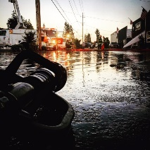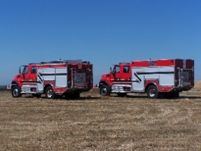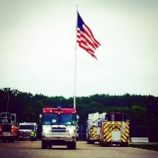
490 Church Street, P.O. Box 247, Aumsville, Oregon 97325-0247
(503) 749-2894 Fax (503) 749-2182 - Email aumsville@aumsvillefire.org

BOARD OF DIRECTORS REGULAR MEETING MINUTES
5604 Shaw Hwy SE, Aumsville
August 8, 2019

Call to order: Meeting called to order by President Garrison at 18:32 hours or 6:32 p.m.

Attendance:
Board members: Joshua Phillis, Garvin Smith, Rachel Fellis, and Robert Garrison
Staff: Chief Roy Hari and Office Administrator Trish Lutgen
Volunteers: Jenn Bratton, Odas Coleman, and Nic Schrock
Special Guest: Krista Carter, Emergency Management

Flag salute: Completed.

Agenda: Needed to add Krista Carter from Marion County Emergency Management presentation for Storm Ready to the agenda and move the Executive Session to the end. Action: Director Fellis made a motion to approve the agenda with the changes, seconded by Director Smith. Motion carried unanimous.

Swearing in of New Directors: Chief Hari swore in the new Board members Director Smith and Director Phillis.

Volunteer Presentation: Chief Hari presented Odas Coleman with a pin and station ring for his 15 years of service.

Minutes: Action: Director Smith made a motion to approve the July 11, 2019 minutes as presented, seconded by Director Fellis. Motion carried unanimous.

Treasurer Report: As presented in the packet.

Volunteer Association: Breakfast on August 17th from 7 a.m. – 11 a.m. If the board will be helping, please be at the Aumsville Station at 6:30 a.m. The Girl Scouts will be helping this year.
Chief Hari stated that the volunteers did a really good job at waterball.

Public Comment: None

Emergency Management Presentation: Krista Carter presented to the Board on the Community Rating System which provides a discount for the public’s flood insurance. She talked about being storm ready which requires three key areas: reception equipment, weathering monitoring, and delivering to the public. Aumsville was the guinea pig, and now they are a storm ready community. They are the first and only in Marion County. There will be a ceremony at City Hall. Krista presented us with a NOAH radio and certificate.

New Business:

EF Recovery: President Garrison read resolution 2019-04 implementing a cost recovery program into record. Action: Director Fellis made a motion to approve resolution 2019-04 as presented, seconded by Director Phillis. Motion carried unanimous. Director Phillis made a motion to have President Garrison sign the contract with EF Recovery to provide soft billing, seconded by Director Fellis. Motion carried unanimous.

Executive Session: In order to conduct deliberations with persons designated by the governing body to negotiate real property transactions per ORS 192.660(2)(e) and to consider information or records that are exempt by law from public inspection per ORS 192.660(2)(f), President Garrison moved into Executive Session at 7:03 p.m.

The Board returned from Executive Session at 7:52 p.m.

Old Business:
- Bradley Property: Nothing to discuss.

- Chief’s Review: Director Fellis and President Garrison are working on policy. They would like the item to appear on the next agenda as informational.

- Wage Schedule: Chief Hari is working on the wage schedule.

- Strategic Plan: Everyone present at the meeting gave great feedback. Director Smith and Kuhl attended along with Lieutenant Surette and Trish.

Chief’s Report: Chief talked to Jeff Dietz and we’ve added Chemeketa students to our fires on the first tone. By the time they arrive our folks would be ready for relief. Within one hour of contacting MetCom the students were added to our first tones. Chief Hari also stated that there was discussion of using their 2nd year students instead of creating a list for our part-time positions.

Good of the Order: Chief presented information on the Social for Safety Conference being held in Reno, Nevada. Chief informed the Board that unless they had any objections, he would like to send Trish to the conference. No objections were given.
It was time for SDAO nominations. The Board decided that they would not be submitting this year.
Director Smith thanked everyone for putting on waterball. It was a lot of fun.

Public Comment: None

Next meeting is September 12th at the Aumsville station at 1830 hours or 6:30 p.m.

Adjourn: Action: Motion to adjourn by Director Fellis, motion seconded by Director Phillis. Motion carried unanimously adjourning the meeting at 2008 hours (8:08 p.m.).

Rachel Fellis, Secretary ______________________________________ Date: __________________

Robert Garrison, President ______________________________________ Date: __________________

